EXP.NO: 5 | Write a Servlet to demonstrate the difference between HTTP GET and POST methods by creating a form and handling requests accordingly.
DATE:05/03/2025

AIM:
To demonstrate the difference between the HTTP GET and POST methods by creating a form in an HTML page and handling the form submissions using two different HTTP methods in a Java Servlet.

ALGORITHM:

Input:
  - The user fills out a web form with their name and email.
  - The form will use both GET and POST methods for data submission.

Steps for Creating and Handling the HTTP GET and POST Requests:
- Create an HTML Form:
  - Design an HTML form with two input fields: one for the name and one for the email.
  - Create two buttons to allow the user to submit the form using GET or POST methods.
  - Use the action attribute to define the Servlet URL and specify the form method (either GET or POST).

Create the Servlet to Handle GET and POST Requests:
  - Write a Java Servlet class that will handle both GET and POST requests.
  - The servlet will have two methods:
    - doGet() to handle the GET requests.
    - doPost() to handle the POST requests.

  - In both methods, retrieve the form data using request.getParameter().
  - In the doGet() method, process and display the data in the URL.
  - In the doPost() method, process and display the data in the HTTP request body.

Handle GET Requests in the Servlet:
  - In the doGet() method, use request.getParameter() to retrieve the name and email submitted via GET.
  - Output the data as a response, including the name and email in the URL (visible to the user).

Handle POST Requests in the Servlet:
  - In the doPost() method, use request.getParameter() to retrieve the name and email submitted via POST.
  - Output the data as a response, displaying the name and email without exposing them in the URL (more secure).

Return the Output:
  - The Servlet should return an HTML page displaying the name and email entered by the user.
  - For the GET method, the output should be visible in the URL.
  - For the POST method, the output should be visible in the response body, not the URL.

Deploy and Test the Servlet:
  - Compile the Servlet class and deploy it to a Servlet container (like Apache Tomcat).
  - Test the form using GET and POST methods to see the difference in data submission.

Observe and Compare GET and POST Results:

  - Test the GET method: The form data is sent in the URL.
  - Test the POST method: The form data is sent in the HTTP request body, not visible in the URL.

PROGRAM:

Exp5.html:

<!DOCTYPE html>
<html>
<head>
<title>Notice Portal</title>
<style> body {
margin: 0;
font-family: "Segoe UI"; background: #f2fcff;
}
header {
background: #004aad; color: white;
padding: 15px; text-align: center; font-size: 22px;
}

.container { width: 85%;
margin: 30px auto; display: ffex;
gap: 20px;
}
.card {
flex: 1;
background: white; padding: 20px; border-radius: 10px;
box-shadow: 0 0 10px #ccc;
}
h3 {
color: #004aad;
}
input, textarea { width: 100%; padding: 10px; margin: 8px 0;
}
button {
width: 100%; padding: 10px;
background: #004aad;

color: white; border: none;
}
</style>
</head>
<body>
<header>STUDENT INFORMATION MANAGEMENT SYSTEM</header>
<div class="container">
<div class="card">
<h3>Search Notices (GET)</h3>
<form action="Servelt4" method="get">
<input type="text" name="keyword" placeholder="Search by keyword">
<button type="submit">Search</button>
</form>
</div>
<div class="card">
<h3>Post a Notice (POST)</h3>
<form action="Servelt4" method="post">
<input type="text" name="title" placeholder="Notice Title" required>
<input type="text" name="dept" placeholder="Department" required>
<textarea name="content" placeholder="Notice Content"
required></textarea>
<button type="submit">Submit Notice</button>
</form>
</div>

</div>
</body>
</html>

Servlet5.java:

import java.io.*; import javax.servlet.*;
import javax.servlet.http.*;
import javax.servlet.annotation.WebServlet; @WebServlet("/Servelt4")
public class Servelt4 extends HttpServlet {
protected void doGet(HttpServletRequest request, HttpServletResponse response)
throws ServletException, IOException { response.setContentType("text/html"); PrintWriter out = response.getWriter();
String keyword = request.getParameter("keyword");
out.println("<html><body style='font-family:Segoe UI;background:#f2f6ff;'>");
out.println("<div style='width:500px;margin:50px
auto;background:white;padding:20px;border-radius:10px;'>");

out.println("<h2 style='color:green;'>Search Results</h2>"); if (keyword != null CC !keyword.isEmpty()) {

out.println("<p>Showing results for: <b>" + keyword + "</b></p>");
} else {
out.println("<p>No keyword entered</p>");
}
out.println("<br><a href='Exp4.html'>Back</a>"); out.println("</div></body></html>");
}
protected void doPost(HttpServletRequest request, HttpServletResponse response)
throws ServletException, IOException {

response.setContentType("text/html"); PrintWriter out = response.getWriter();

String title = request.getParameter("title"); String dept = request.getParameter("dept");
String content = request.getParameter("content");
out.println("<html><body style='font-family:Segoe UI;background:#f2f6ff;'>");
out.println("<div style='width:500px;margin:50px
auto;background:white;padding:20px;border-radius:10px;'>");
out.println("<h2 style='color:#004aad;'>Notice Posted Successfully</h2>");
out.println("<p><b>Title:</b> " + title + "</p>"); out.println("<p><b>Department:</b> " + dept + "</p>"); out.println("<p><b>Content:</b> " + content + "</p>");

out.println("<br><a href='Exp4.html'>Back</a>"); out.println("</div></body></html>");
}
}

Output:

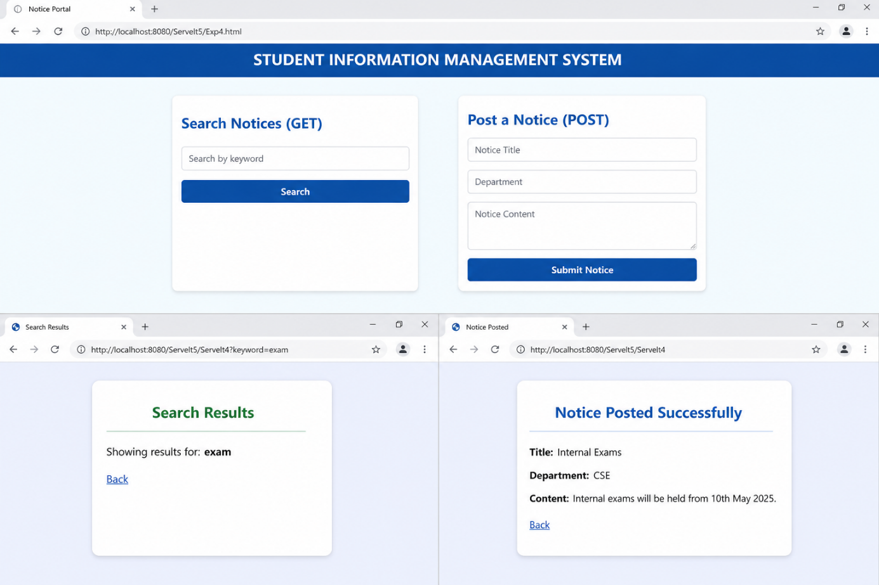

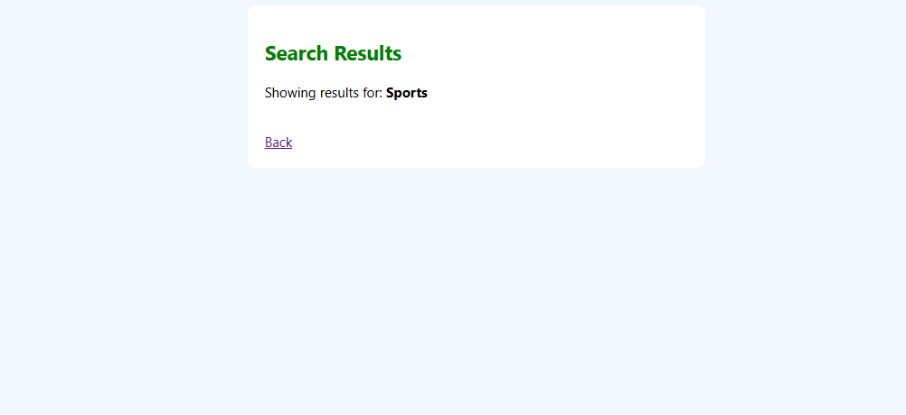

RESULT:
A Servlet is created to demonstrate the difference between HTTP GET and POST methods by creating a form and handling requests accordingly.

